IMAPS - Public Service Interoperability Assessment Model

Introduction
This online survey allows public service owners to assess the level of interoperability achieved by the digital public service they provide. It uses the Interoperability Maturity Assessment of Public Service (IMAPS) model to help public authorities understand two key aspects of their interoperability performance:
the current level of interoperability achieved by the public service, and the priority areas for improvement to further increase their level of interoperability.
The IMAPS survey measures the effectiveness of a public authority's communication with external bodies to ensure the efficient delivery of public services to other public authorities, businesses and/or citizens. The IMAPS survey helps public service owners to improve the quality of services provided, reduce costs, solve integration problems by reusing available services and organise services efficiently to maximise service outputs and benefits for citizens and public authorities.
Interoperability of a digital public service can be defined as "its characteristic that determines the extent to which a service enables collaboration between public services to achieve mutually beneficial objectives, including the sharing of data, information and knowledge, regardless of their legal, organisational, semantic and technical environment".
Interoperability is multi-dimensional in nature and includes structural interoperability, behavioural interoperability and management interoperability:
- structural interoperability is defined as "the extent to which its structure has been developed through the reuse and/or sharing of its components in support of interoperability",
- behavioural interoperability means 'the extent to which data, information or knowledge is exchanged with the environment in support of interoperability within its behavioural manifestations',
- management interoperability means 'the extent to which its agreed coordination rules support interoperability'.
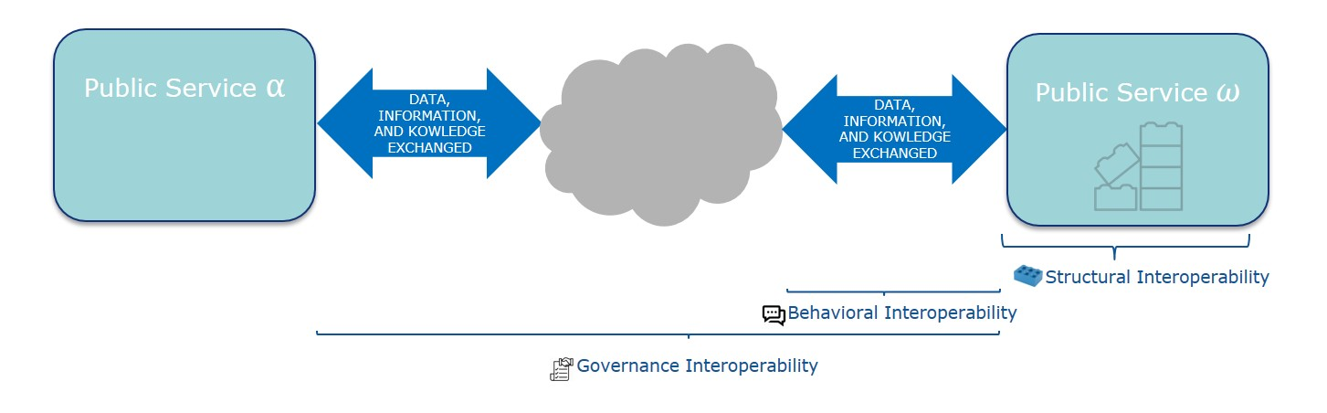Image

Background
The Interoperability Achievement Model is implemented with the support of the ISA² programme. The ISA² programme is a €131 million European Commission programme that develops digital solutions to deliver interoperable cross-border and cross-sector public services benefiting public administrations, businesses and citizens across the EU.
The IMAPS survey version 1.2.0 is an updated version of IMAPS survey version 1.1.1 and is fully aligned with the European Interoperability Framework (EIF) and can therefore be used to gauge the level of implementation of the EIF framework.
The EIF Interoperability Principles are the basic behavioural elements that guide interoperability measures. They describe the context in which European public services are designed and implemented.
The twelve interoperability principles of the new EIF framework (subsidiarity and proportionality, openness, transparency, reusability, technology neutrality and data portability, user-centricity, inclusiveness and accessibility, security and privacy, multilingualism, administrative simplification, information retention and assessment of effectiveness and performance) together fulfil the objectives for achieving interoperability: to achieve legal, organisational, semantic and technical interoperability (L, O, S, T).
The IMAPS survey assesses the level of behavioural interoperability by examining the most important aspects of each interoperability element (legal, organisational, semantic and technical).
In this context, the IMAPS survey specialisation areas allow public service owners to evaluate, improve and assess key aspects of behavioural interoperability of their public service, exploring the context of service provision and usage by assessing the legal (LIMAPS), organisational (OIMAPS), technical (TIMAPS) and semantic (SIMAPS) behavioural interoperability of their digital public service.

This survey
This survey focuses on both owners of digital public services and those who support their deployment, such as enterprise architects and vendors. It can be completed online.
Designed as a self-assessment tool, the IMAPS survey consists of a set of questions designed to assess key aspects of public service interoperability behaviour. It results in individual feedback, which is confidential, and recommendations for service improvement.
The IMAPS survey was designed to evaluate services that are provided and used by end-users (i.e. services provided directly to users, so-called 'front-office services') and by other IT systems (i.e. support services, so-called 'back-office services').
In relation to the level of interoperability achieved, the IMAPS survey measures the effectiveness of digital public service communication with other organisations to achieve mutually beneficial and agreed common goals through information exchange and service reuse.
The figure below illustrates all possible cases where interoperability of a digital public service with the outside world may occur:
service provision (D) - provision of a digital public service, service usage (C) - use of reusable services for machine-to-machine communication between other public administrations and enterprises, This may include the use of functions, core registry information and security services, service management (B) - management and monitoring of the process related to service communication with the external domain from initiation to provision of outputs. Aspects of service management that fall into this area include, for example, enterprise architecture, procurement and service level management.
The figure below illustrates the areas of interoperability that are measured in the IMAPS survey, which specify where interoperability plays a role in terms of service provision, service usage and service management.
The questionnaire should take approximately 20 to 30 minutes to complete as part of the IMAPS survey. Once completed, a report will be generated containing the resulting level of interoperability, including recommendations for further improvement of your public service.

Expected benefits
Provides immediate insight into the interoperability of the public service and individual recommendations for potential improvements to the interoperability of the service.
Measures the effectiveness of digital public service communication with other organisations to achieve mutually beneficial and agreed common goals through information exchange and service reuse.
It provides an opportunity to determine the state of interoperability of the public service and to improve it at any time throughout the life cycle of the public service.
Upon request, it shall provide a peer comparison with the levels of interoperability achieved by other public services.
Applicability to all national digital public services in the European Union across all domains, from public data portals to e-voting platforms to procurement services, etc.
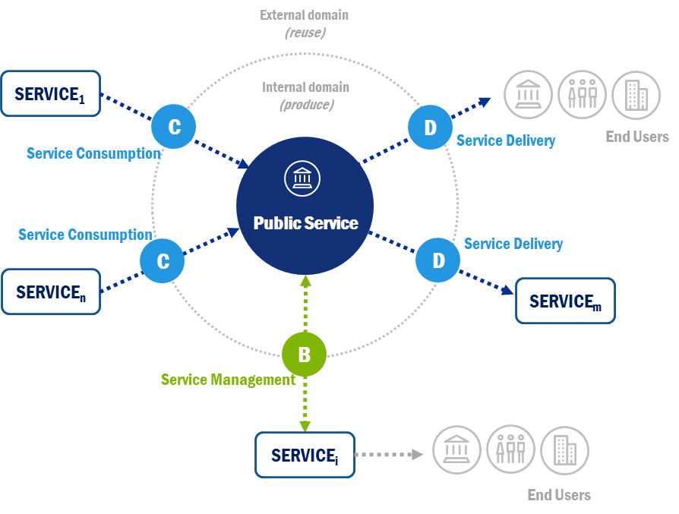Image

Service Identification (A)
In this section, answer the following questions about your public service.
- A1A. State your name:
- A1B. Provide your email address:
- A1C. Please provide your telephone number:
- A1D. Indicate the country in which the organisation providing the digital public service is located: * A2A. A digital public service is a digital service provided in the public interest. What is the name of the digital public service you provide to end users (citizens, businesses or other public authorities) .
- A2B. Use the following criteria to define a digital public service: i) process and related activities, ii) mode of delivery, iii) owner (see A3).
- A2C. Method of delivery: how does the digital public service deliver outputs to a group of end users?
- A3. Owner: Which public authority is primarily responsible for delivering the digital public service?
- A4. Identify the sector in which the digital public service is provided. . * A5. To which group of end-users is the digital public service provided? * A6. Indicate at which administrative level the digital public service is provided (multiple answers are possible). .

Service provision (D)
The public authority provides the digital public service to end users, i.e. citizens, businesses or other administrative authorities. This process is called service provision. The service provided is key to the IMAPS survey in order to correctly define the scope and the digital public service being assessed. If the scope of the service provided is defined correctly, scoping other areas will be easier.
The scope of service provision focuses on the data, information and knowledge provided by the digital public service, the key drivers of service provision and the manifestations of service provision.
Answer the following questions about how your digital public service is delivered to end users and/or other public services.

Data, information and knowledge provided
Assesses interoperability specifications for behaviour relating to data, information and knowledge provided by the public service to end users and/or other customer services.
- D1. In what format does your digital public service publish its publicly available data? Key factor/ Manifestation From the perspective of the EIF Interoperability Framework: L. O. S. T
- D2. To what extent are existing semantic standards and specifications used for data provision? Key factor/ Manifestation From the perspective of the EIF Interoperability Framework: L. O. S. T

Key Service Delivery Factors
Assesses the behavioural interoperability capabilities that enable either (i) the delivery of data, information and knowledge by a digital public service to end users and/or other customer services or (ii) the traceability of a public service.
- D3. Are data protection issues (e.g. scope of data stored, purpose of data use, right to request changes or lodge a complaint, relevant data protection regulation, retention policy) transparent to users? Key Factor / Manifestation From the perspective of the EIF Interoperability Framework: L. O. S. T
- D4. To what extent is multilingualism supported? Key factor / Manifestation From the perspective of the EIF Interoperability Framework: L. O. S. T
- D5. Is this digital public service part of a catalogue of services? Key factor / Manifestation From the perspective of the EIF Interoperability Framework: L. O. S. T
- D6. Have any authentication mechanisms been put in place to identify persons? Key factor / Manifestation From the perspective of the EIF Interoperability Framework: L. O. S. T
- D7. Has there been a certification process for end users to access the digital public service? Key factor / Manifestation From the perspective of the EIF Interoperability Framework: L. O. S. T

Service Delivery Projections
Assesses the manifestations of interoperability behaviour of a public service providing data, information and knowledge. (Manifestations may take the form of performance, outcomes, user experience.)
- D8. What are the channels through which the digital public service is delivered to users? Key factor / Manifestation From the perspective of the EIF Interoperability Framework: L. O. S. T
- D9. Does the digital public service use pre-populated data and information for the requested data and information? Key factor / Manifestation From the perspective of the EIF Interoperability Framework: L. O. S. T
- D10. Are the administrative rules and processes underlying the digital public service (e.g. decision-making mechanisms, timelines, information sources used, reporting obligations) transparent to the end user and explained in a simple and understandable way? Key Factor / Manifestation From the perspective of the EIF Interoperability Framework: L. O. S. T
- D11. Can users send feedback on the quality of the digital public service? Key factor / Manifestation From the perspective of the EIF Interoperability Framework: L. O. S. T
- D12. Is the digital public service accessible to people with (e.g. visual, hearing, physical, cognitive) disabilities to a comparable extent as other users? Key factor / Manifestation From the perspective of the EIF Interoperability Framework: L. O. S. T
- D13. Is the provision of the digital public service properly constrained in any way (e.g. at local, national or EU level)? Key factor / Manifestation From the perspective of the EIF Interoperability Framework: L. O. S. T

Use of the service (C)
When providing a digital public service to an end user, the digital public service may be required to use the services of other public authorities or businesses. This area is called use of service.
There are different types of services that can use digital public services:
Functional Service - a common function (e.g. licensing, procurement, planning, risk assessment module) shared between organisations; Security Service - a specific type of functional service for sharing common security functions (e.g. identity management and verification) between organisations; Basic Registry Service - a specific type of functional service for sharing trusted, reliable and verified data (e.g. on citizens, land, vehicles) between public authorities.
The interoperability of digital public services that, where possible, use (reuse) existing services is considered to be higher than that of privately owned services by organisations that create (develop) them without reusing existing functionality.
This section includes 'data, information and knowledge used', 'key drivers of service use' and 'manifestations of service use'.
Answer the following questions about the use of your digital public service.

Data, information and knowledge used
Assesses the interoperability specifications for the behaviour of data, information and knowledge used by the public service from other server services.
- C1. How does the digital public service currently use other services (manually or digitally)?
- C2. Does the digital public service use services repeatedly or does it develop the used services itself? Key factor / Manifestation From the perspective of the EIF Interoperability Framework: L. O. S. T

Key drivers of service usage
Assesses the behavioural interoperability capabilities that enable either (i) the use of data, information and knowledge by a digital public service for end users and/or other customer services or (ii) the traceability of the public services used.
- C3. Does the digital public service have legal means in place to ensure the use of the service? Key Factor / Manifestation From the perspective of the EIF Interoperability Framework: L. O. S. T
- C4. Indicate how you handle the data used by your digital public service. Key Factor / Manifestation From the perspective of the EIF Interoperability Framework: L. O. S. T

Service usage manifestations
Assesses the manifestations of interoperability behaviour of a public service using data, information and knowledge.
(Manifestations can be in the form of performance, outcomes, user experience.)
- C5.1. Select the services that your digital public service must use in order to function: Important note: List the services that are used both within the administration (internally) and from third parties (externally). Please list the services used both manually and digitally. Key factor / Manifestation From the perspective of the EIF Interoperability Framework: L.O.S. T * C5.2. Subsequent: List all relevant specific services that are necessary for the functionality of your digital public service. Again: List the services that are used both internally by the administration (internally) and from third parties (externally). Indicate both the services used manually and digitally. Key factor / Manifestation From the perspective of the EIF Interoperability Framework: L.O.S. T
- C5.3 Based on the above general and specific services, confirm whether the use of the service includes data exchange.
- C6. Does the digital public service use services from different levels of government (e.g. from different Member States, from different organisations)? Key Factor/Disclosure From the perspective of the EIF Interoperability Framework: L. O. S. T
- C7. Does the digital public service subscribe to automatic service updates (e.g. life events) in order to trigger the provision of its services and/or update information? Key Factor / Manifestation From the perspective of the EIF Interoperability Framework: L. O. S. T

Service Management (B)
This area focuses on important aspects of service management in the area of sharing and reuse and the concept of digital public service. It is considered that interoperability of digital public services is enhanced when documentation, source code, services and support are provided to other administrations and businesses for reuse. This area also includes important aspects of the concept that ensure future-proof interoperability, such as its architecture, processes, procurement orchestration and service level management.
This section includes 'data, information and knowledge management', 'key service management enablers' and 'service management manifestations'.
Answer the following questions about the governance of your digital public service.

Data, information and knowledge management
Assesses the interoperability specifications of behaviour in terms of data, information and knowledge management by a public service.
- B1. To what extent has the integrated public service been designed according to the Framework Reference Architecture Model? Key factor/ Manifestation From the perspective of the EIF Interoperability Framework: L. O. S. T
- B2. Do you have processes in place for data and metadata management? Key factor/ Manifestation From the perspective of the EIF Interoperability Framework: L. O. S. T
- B3. In which of the following areas (legal, technical, organisational, semantic) have the recommendations of the EIF framework been taken into account? Key factor / Manifestation From the perspective of the EIF interoperability framework: L. O. S. T
- B4. Does your digital public service comply with any aspects of the European Interoperability Reference Architecture (EIRA)? Key factor / Manifestation From the perspective of the EIF Interoperability Framework: L. O. S. T
- B5. Which of the following procedures has been put in place to verify the consistency of data, information and knowledge exchanged/managed by the public service? Key factor / Manifestation From the perspective of the EIF Interoperability Framework: L. O. S. T
- B6. In which of the following areas of interoperability (legal, technical, organisational, semantic) do you intend to develop a catalogue of specifications and standards? Key factor / Manifestation From the perspective of the EIF Interoperability Framework: L. O. S. T

Key drivers for service management
Assesses the interoperability capabilities of behaviours that enable a public service to manage data, information and knowledge.
- B7. Indicate whether and how the digital public service shares its components and knowledge with the external environment. Key Factor / Manifestation From the perspective of the EIF Interoperability Framework: L. O. S. T
- B8. Do you have a security profile set up within the service? Key factor/ Manifestation From the perspective of the EIF Interoperability Framework: L. O. S. T
- B9. How is data protection ensured? What measures have been put in place? (multiple answers possible) Key factor/Statement From the perspective of the EIF Interoperability Framework: L. O. S. T
- B10. Are there service level agreements in place for the digital public service? Key Factor/Statement From the perspective of the EIF Interoperability Framework: L. O. S. T

Service management projections
Assesses the manifestations of interoperability behaviour of the public service in the area of data, information and knowledge management
(Manifestations can be in the form of performance, outcomes, user experience.)
- B11. Are all contractual terms and conditions for the operation of the digital public service clearly and explicitly defined? Key Factor / Manifestation From the perspective of the EIF Interoperability Framework: L. O. S. T

